Instructions for Using the Roll Call GUI

## Monica Pagán Spring 2021

**Contents**

GUI 1

How to Use the GUI 1

Notes 3

# GUI

These instructions are written for the use of the Roll Call graphic user interface (GUI) that was created Spring 2021. This GUI takes roll call CSV files and reads in their ‘Longitude’ and ‘Latitude’ columns through the program GeoPandas. This helps create roll call shapefiles that can be output into the directory of the users’ choice. The GUI will also output a map that can be viewed by the user in the directory that they have chosen. A textfile will be sent into the output directory of the users’ choosing with concise information on each of the points presented on the map

# How to Use the GUI

1. The first step is to create an output folder that you would like the shapefiles, map

and textfile to be output to. In this case an example folder could be named ‘output’.

This can be seen below.

**NOTE:** Create a new folder where you would like to put the new files that you will create. Make sure to label this with the name of the city that you are creating the files for. An example would be ‘washington_output’.

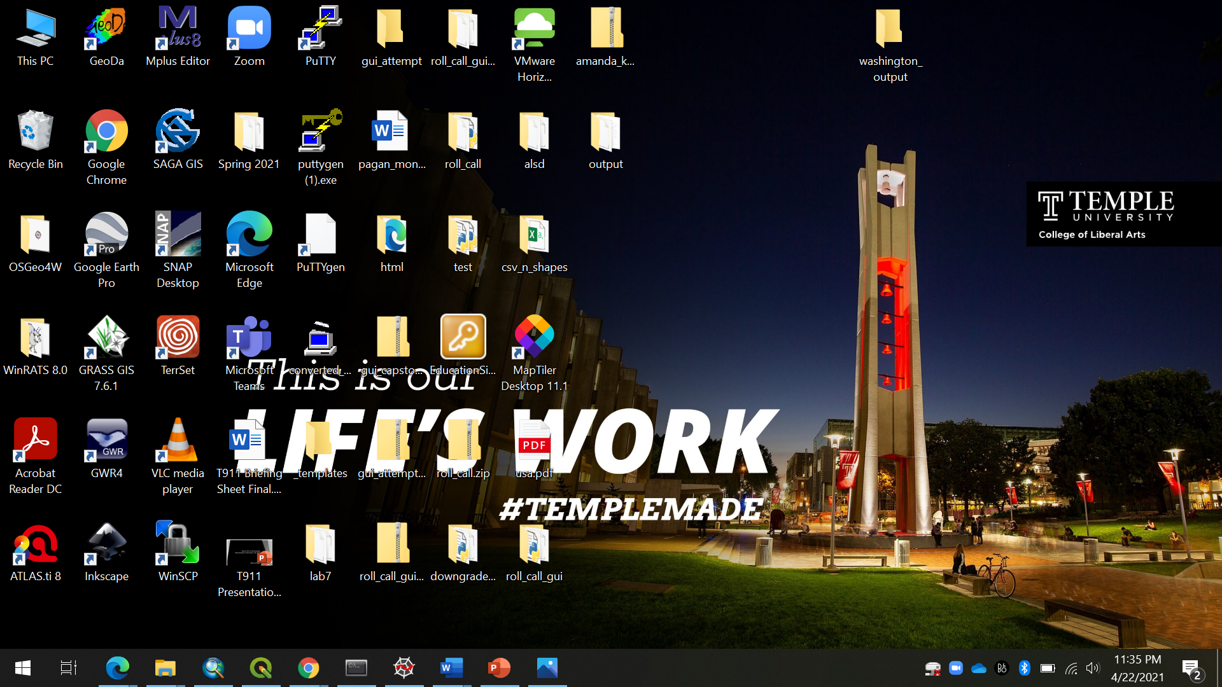

2. The second step would be to copy the filepath where the roll call CSV is

located and put it into the first line of the GUI.

**NOTE:** Create a new folder where you would like to put the new files that you will create. Make sure to label this with the name of the city that you are creating the files for. An example would be ‘washington_output’.

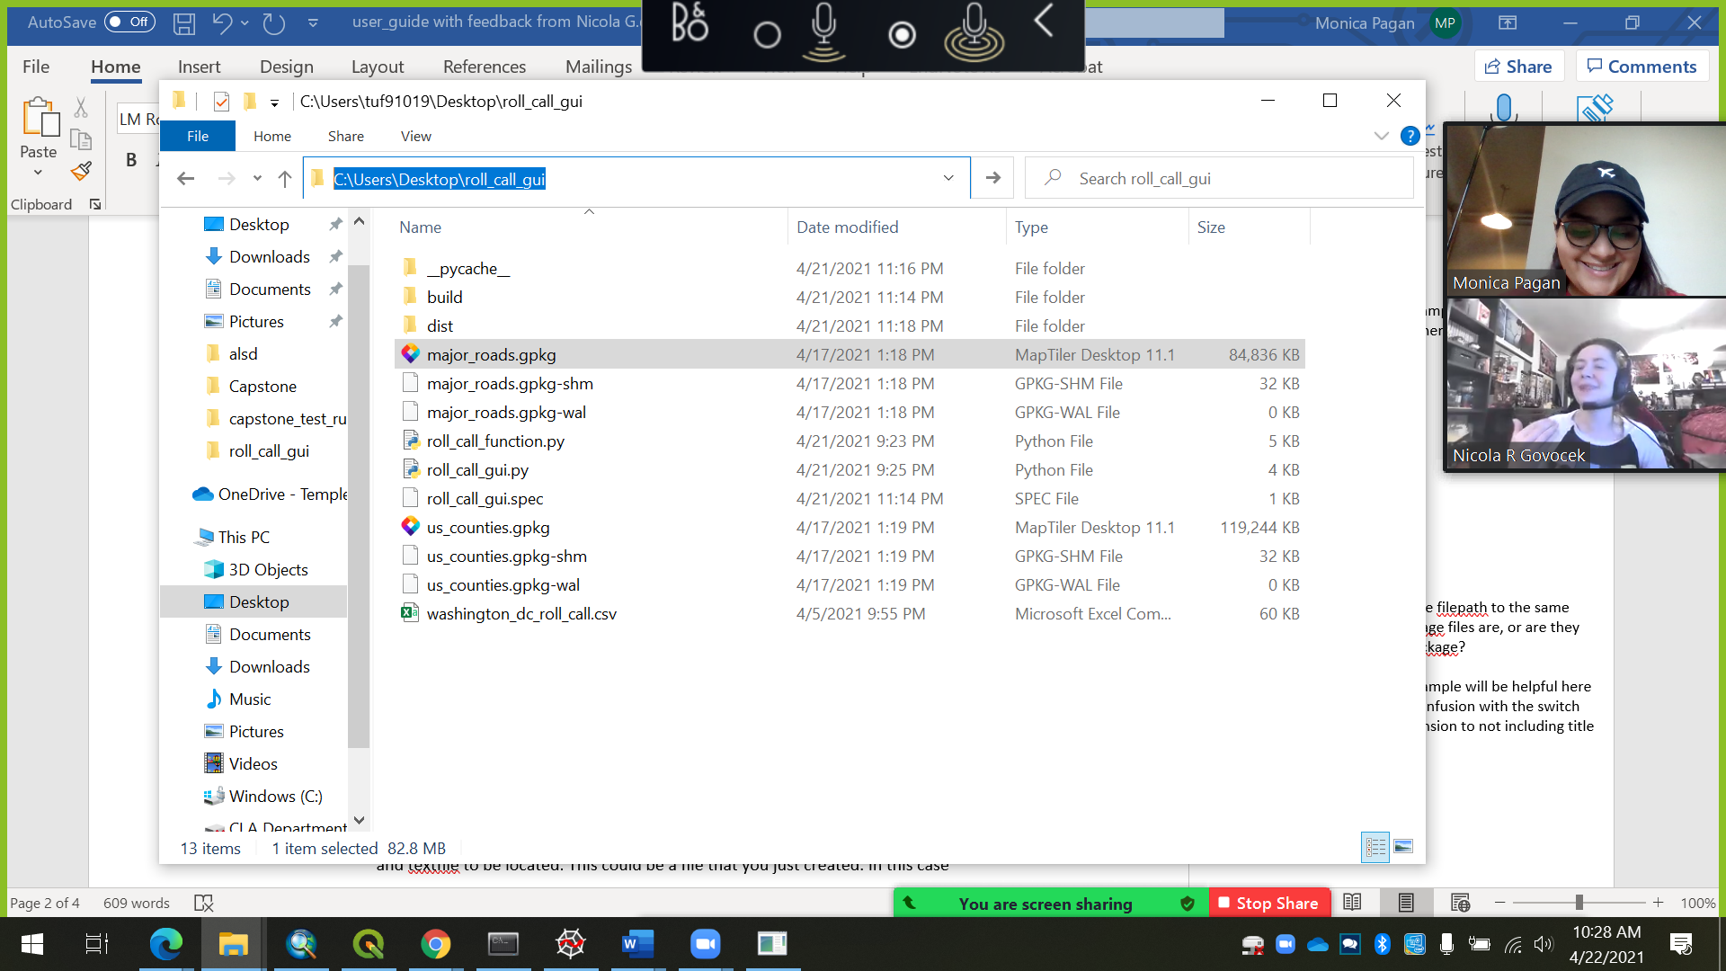

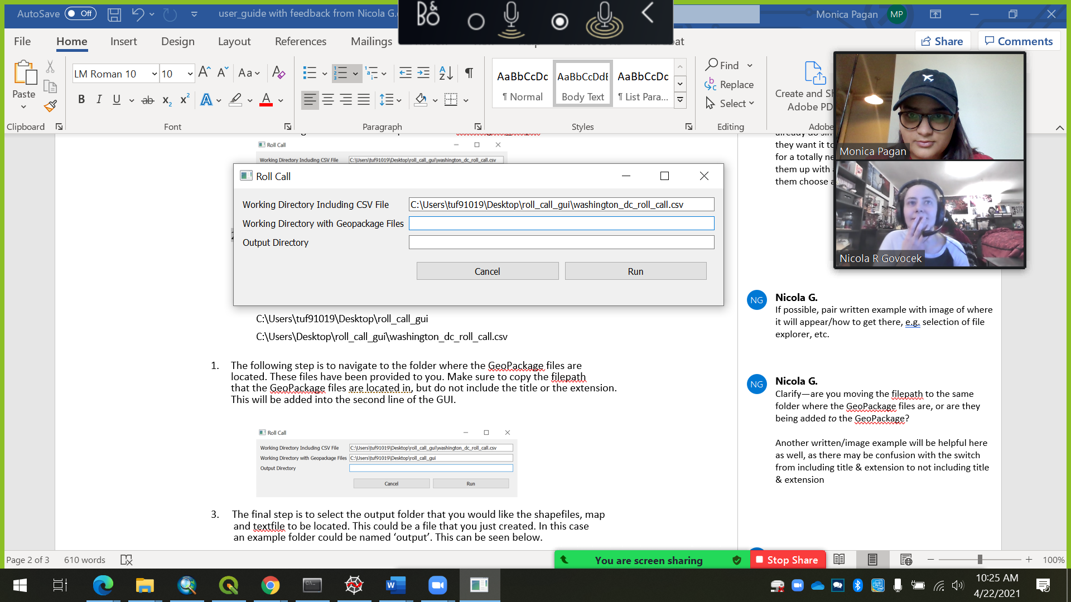

3. The third step is to navigate to the folder where the GeoPackage files are

located. These files have been provided to you. Make sure to copy the filepath

that the GeoPackage files are located in, but do not include the title or the extension.

This will be added into the second line of the GUI.

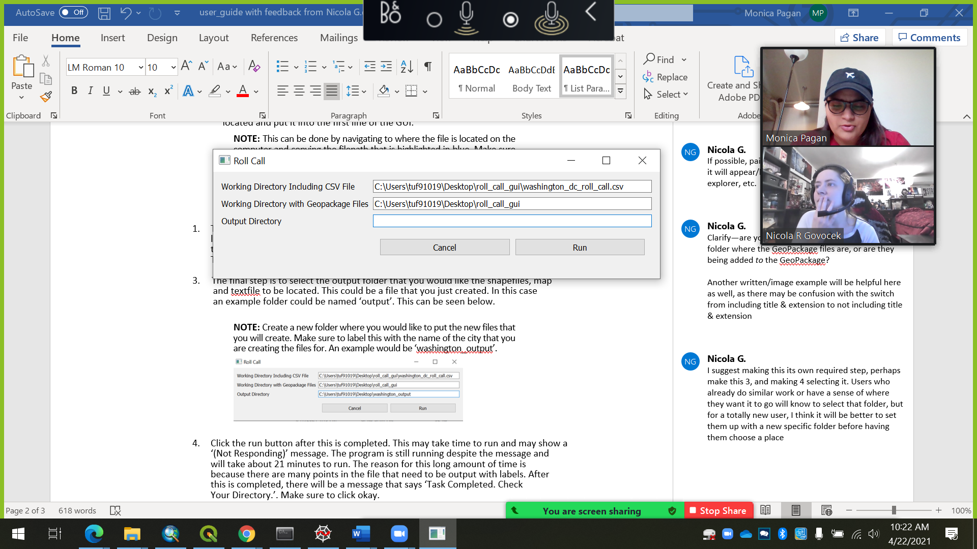

4. The fourth step is to select the output folder that you would like the shapefiles, map

and textfile to be located. This could be the file that you created in the first step. In this case,

the example folder has the name ‘washington_output’. Paste the filepath into the third

slot of the GUI as seen down below.

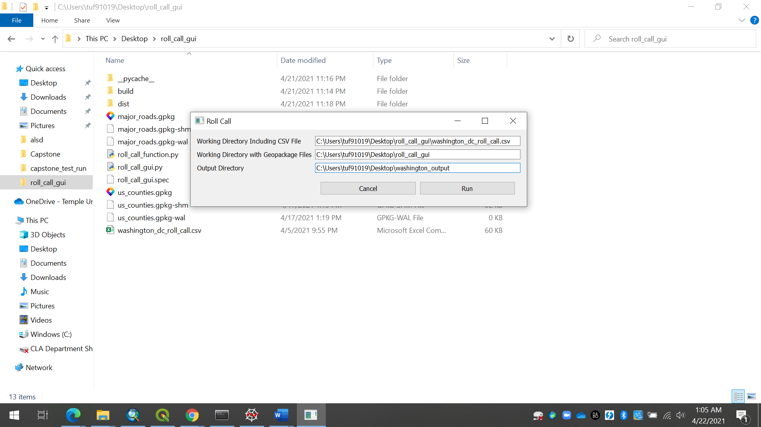

1. Click the run button after this is completed. This may take time to run and may show a

‘(Not Responding)’ message. The program is still running despite the message and

will take about 21 minutes to run. The reason for this long amount of time is

because there are many points in the file that need to be output with labels. After

this is completed, there will be a message that says ‘Task Completed. Check

Your Directory.’. Make sure to click okay.

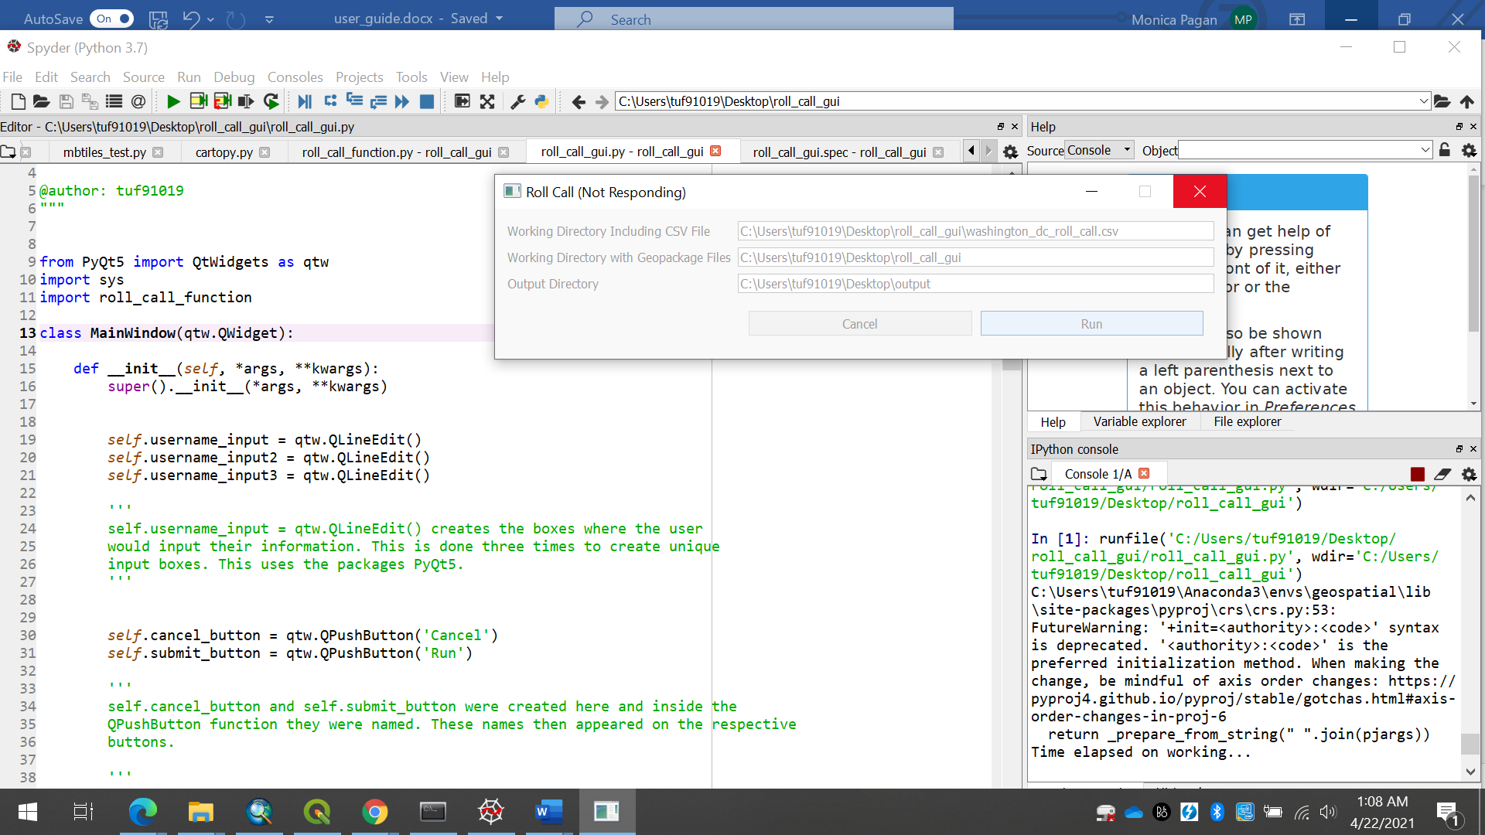

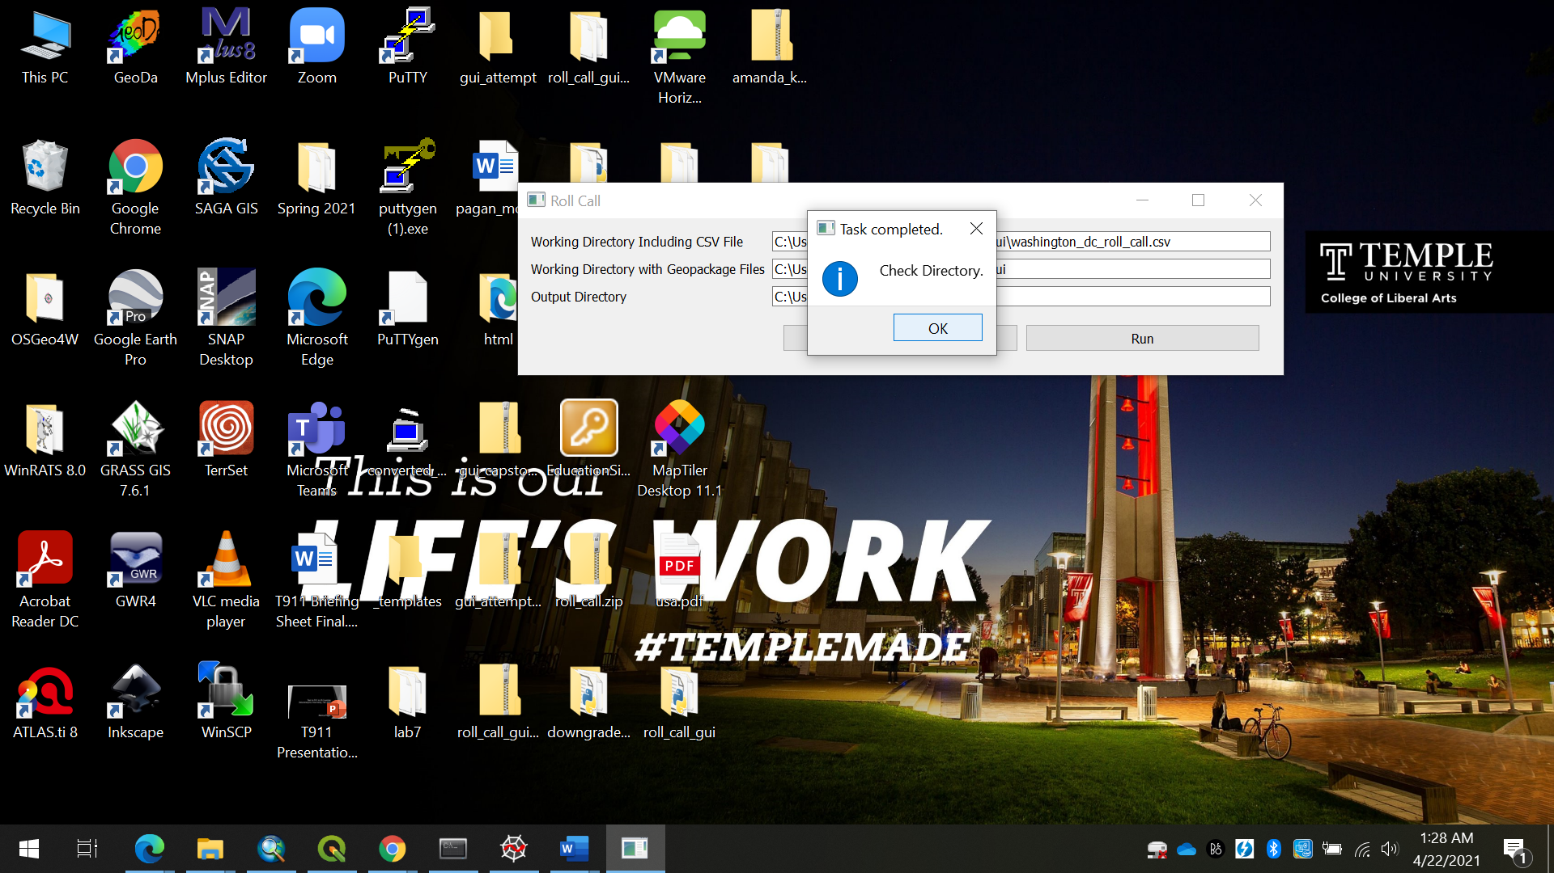

1. Check your directory and make sure that the shapefiles that were created are in the folder you created. Here you will also find the map and the textfile. The map may take some time to load when you open it as it is big file.

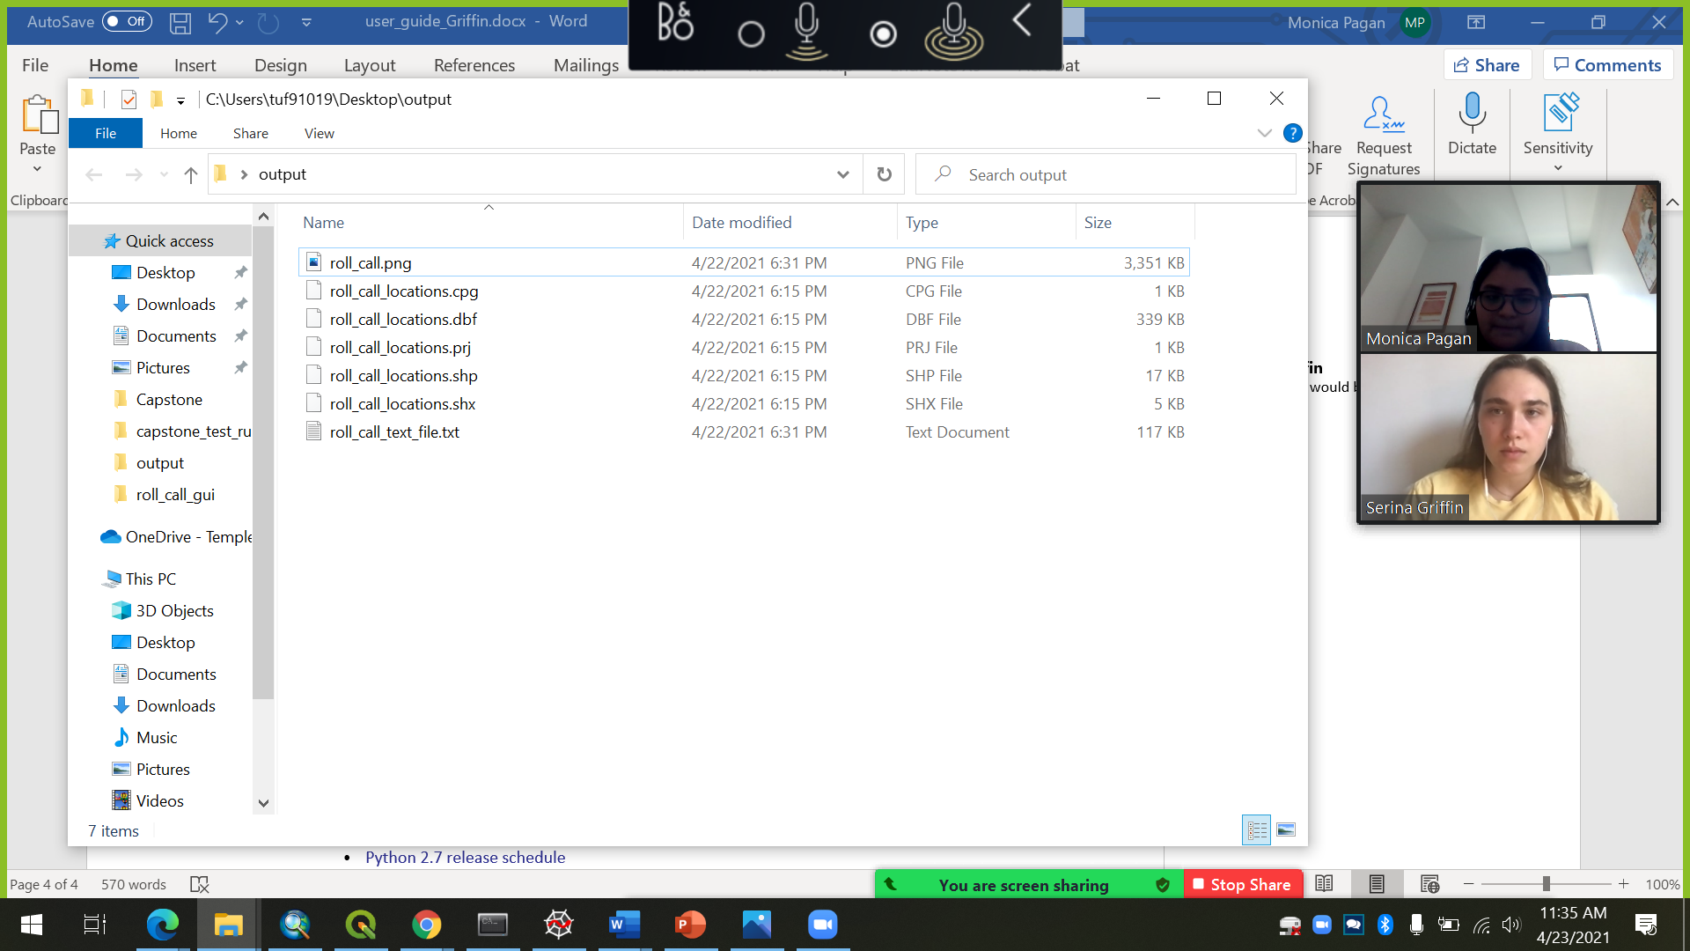

# Notes

# The current roll_call_gui.py file takes about 20 minutes to run fully as there are over

# 600 locations that need labels as well as their text adjusted.

# The black lines indicate major roads and grey lines indicates counties. The green points are

# the locations for each of the AM, FM, TV and other services.